21 IDEAS BLUEPRINT

the top typeS of Productivity Tools

To Rock Your Coaching Business
Productivity is not just about tools. Here are twenty-one ideas for increasing your productivity, as well as making the most of any type of productivity app, software or strategy.
- Start with the Most Important Productivity Strategy
Before installing any productivity tool, first determine which part of your business you need to systematize and hand off. Look for the most:
- Time-consuming part of your business
- Energy-draining tasks of your business
- Area of your business where you lose the most money
- Area of your business that makes you feel as if you’ve wasted hours
Start with a productivity tool that takes care of the most urgent areas—be that scheduling, customer support, billing or all of the above—and fit your solution to meet that need with as few tools—or steps—as possible.
- Stop the Endless Cycle
Do you buy course after course, promising yourself you’re going to “master” an area of your business that is not second nature to you? Do you have courses and eBooks on your computer that you’ve never completed (or perhaps never even started?)
These are big clues to your ‘weak’ areas—the ones you should waste no more time on, but immediately outsource or automate.
- Learn to be Mindful and In the Moment
If you’ve made a commitment to be more aware of your business overview and vanquish self-sabotaging habits, then pay attention to that commitment. If you find yourself doing time-waster tasks on autopilot, or spending hours trying to tweak one headline, or letting time slip away on Facebook—stop. Take frequent reality checks during the day. Get up from your computer, and take a moment to appreciate the weather outside (bad or good); the comforts of your office; even the fact that you are alive and breathing.
Doing this can help you break bad habits—as long as you make this your new habit!

- Underestimate on Purpose
Perfectionists have a lot of bad habits. The worst one? Being a perfectionist! Stop overestimating your ability to be super-coach. Keep your to-do list essentials simple: No more than three key tasks per day. Then time those three things; at least for a few weeks.
After you’ve concluded this experiment, start allotting a time frame to each task, based on the actual time-frames.
And if something takes too long? Automate or outsource!
- Sync Your To-do List with Your Scheduling Software or Calendar
Reserve some appointment slots for yourself, to accomplish tasks you have to do yourself.
- Hire a Coach
As a coach you know that your lovely, intelligent clients often just can’t see the forest for the trees.
That applies to you as well. Invest in coaching for yourself, zeroing in on problem areas, to increase your productivity in areas you didn’t even realize were problems.
- Create Templates and Checklists for Recurring Tasks
Checklists and templates provide a quick way to make sure you create consistency in your content and communications.
They also save time, and allow you to hand off completion to assistants.
- Plan Your Schedule at the End of the Day
That way, when you sit down at your desk the next morning, you’ll feel prepared and be focused and ready to go.
- Plan to Repurpose Everything
Every step you take as a coach—down to even making mistakes—is fodder for sharing. So make sure you take notes, keep a daily journal and/or record as much as you can, keeping in mind how to repurpose it later.

- Shut All Your Browser Tabs Down
We all do it—have a gazillion tabs open while working. If you find yourself feeling overwhelmed and muddled, shut them all down and start afresh.
(And if you really want to save items, use Evernote and its “Clip to Web” extension to quickly save your tabs for later, or copy-select images or bits of text from your online research.)
- Do Your Most Important and/or Most Unpleasant Task First
Procrastinators do the most important or most unpleasant task last.
Do these tasks first and get them out of the way, and you’ll be more energized as you step into the rest of the day.
- Learn to Use Macros and Keyboard Shortcuts and Fixes
Every time you learn to use a new macro or keyboard shortcut—record it! Keep them in a page at the back of your journal or in a file right on your desktop. (This is especially important for those macros, shortcuts and fixes you only use occasionally, so that you don’t have to look them up all over again.)
- Use a Central Password Manager
If you’re not already doing so, take the time to sign up for either LastPass or RoboForm password manager. After you’ve set it up, any time you add a new site and create a password, LastPass will offer to save it for you.
That way, you only ever have to remember one central password (for your password manager). And you’ll never have to reset your other passwords multiple times or hunt around for the latest version again.
- Be Proactive: Not Reactive
Too many coaches get caught up in chasing around after clients and after the latest coaching ‘fashion’.
Focus instead on the lifestyle you want, plan your steps to achieving it and set healthy boundaries. Focus on that—not on mastering the latest Webinar platform or letting clients trample on your boundaries.

- Try Coach.Me
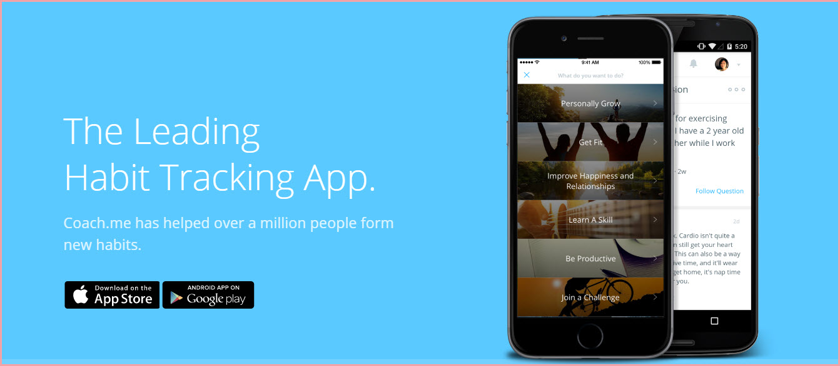
An easy way to analyze your daily habits is to use the free Coach.me habit tracker app. No more keeping time sheets, or writing in notepads. No more journaling your habits.
It’s available for both Apple and Androids, so you can auto-track yourself anywhere.
Now that’s productive!
- Break Major Goals into Tiny Bites
It’s far easier to reach the other side of the country one step at a time, rather than focusing on how far away and unreachable it feels.
Celebrate each step, and celebrate key milestones along the way even more. And remember that even the most famous musician in the world had to learn to keep at it, and learn one lesson at a time.
- Twenty-Minute Naps Boost Productivity
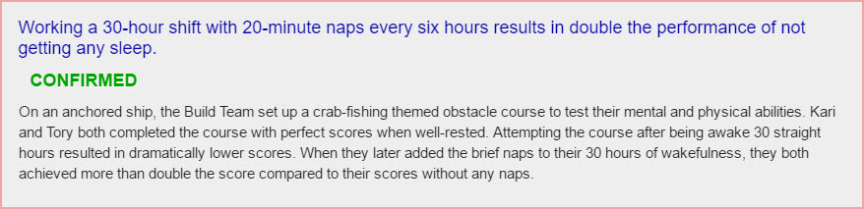
Rather than reaching for another cup of coffee, schedule yourself room for a twenty-minute nap during the day.
The TV show “Mythbusters” tested this myth extensively, and proved that naps of twenty minutes (no more, no less) produced the most optimal results.
- Get Up An Hour Early
“If I only had an extra hour a day”, you may have said. So make one! Get up an hour early (even two or three hours early, if you can hack it) and see what you can accomplish when the world is quiet and everyone else in the house is still asleep.
(This is a tip enthusiastically espoused by many proactive millionaires.)
- Untrain Your Brain
We have now hard-wired ourselves, quite literally, to multi-task—something that as of recent years has been venerated.
Psychologists have proved that multi-tasking dissipates energy and makes us feel duller and more confused later in the day. Furthermore, multi-tasking drops IQs by an average of 5 points, according to one source.
Focus on one task at a time, and shut off (and out) all other distractions.
- Shop Online as Much as Possible
While shopping may be relaxation for some people, it’s sheer drudgery and time wasting to others. If that sounds like you, remember that even your grocery shopping can be done online (and delivered to your door)!
Keep personal activities that really count and enrich your life—like going to your daughter’s hockey game or going for your morning run—but get rid of the tedious stuff. “Outsource” it!
- Keep Things Fun
It’s not rocket science to note that we humans tend to abandon activities or tools that are stressful, difficult or boring. No matter what new habits or tools you decide to use to increase productivity, make sure that you find them easy to adopt—and fun to use.
Productivity is really just another way to make sure your quality of life—as well as your business and your relationships with others—rocks. Being truly productive keeps you energized, inspired and heading straight towards your dreams.

